Readme

The program generates random mazes VIA the binary tree algorithm. To begin, I did some research with python’s syntax to learn basic commands as this is my first-time writing code in python.

The grid was the easy part as it was just drawing lines using nested for loops. It however took me a couple of hours to learn the syntax for python and code to implement the grid in the program. After this the real hurdle began. I initially started off with the recursive backtracker algorithm, however I could not get the list to correctly read the coordinates. I tried everything for a couple of hours before eventually ditching the backtracker code and moving on to the binary tree algorithm.

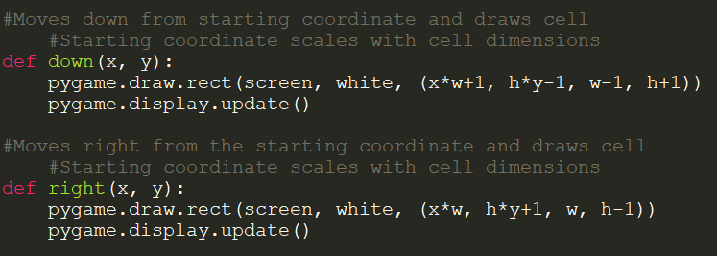The binary tree algorithm was much simpler than the backtracker code as it did not require any lists or coordinates to be stored. The hardest and the longest part to this algorithm was making the “down” and “right” functions in my code as they took a lot of trial and error to get them to display correctly.

As can be seen from the picture, the program generates the maze by covering up the grid which was initially created using blank rectangles.

The program:   
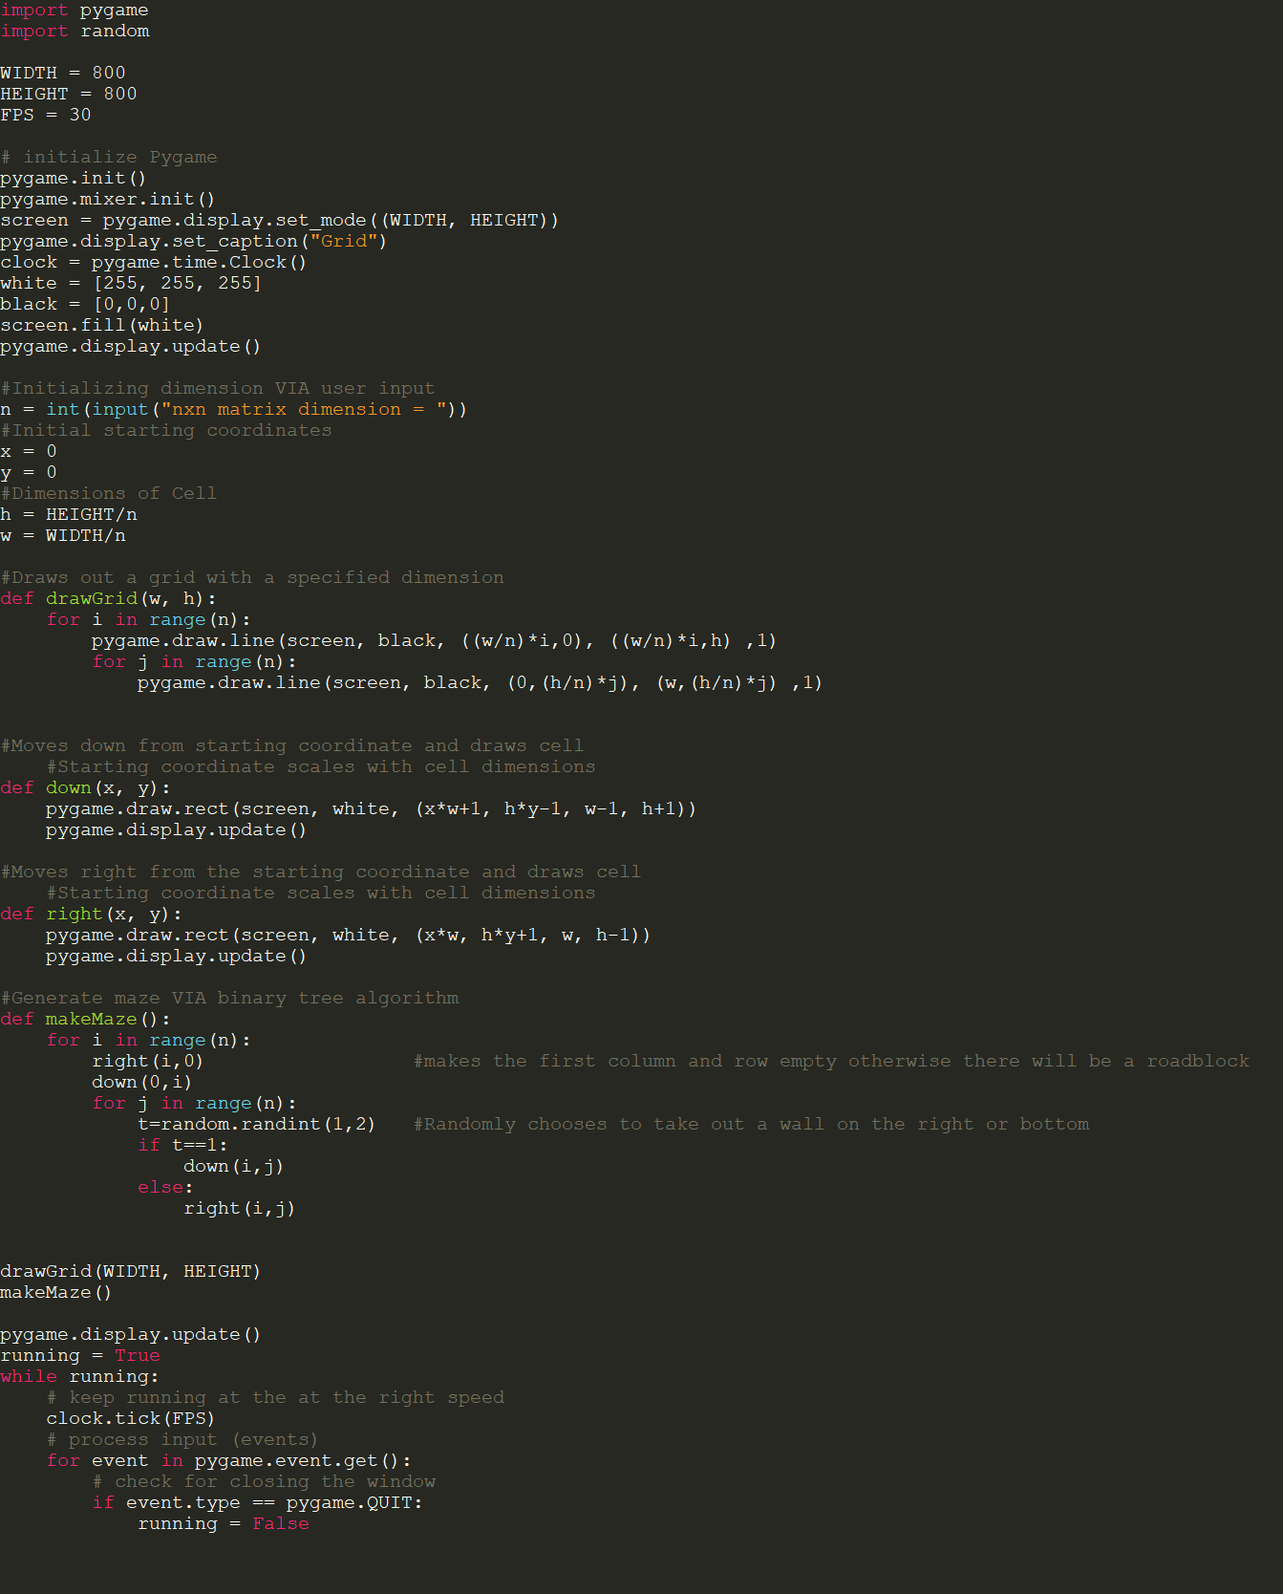

This is the final result generated by the program:

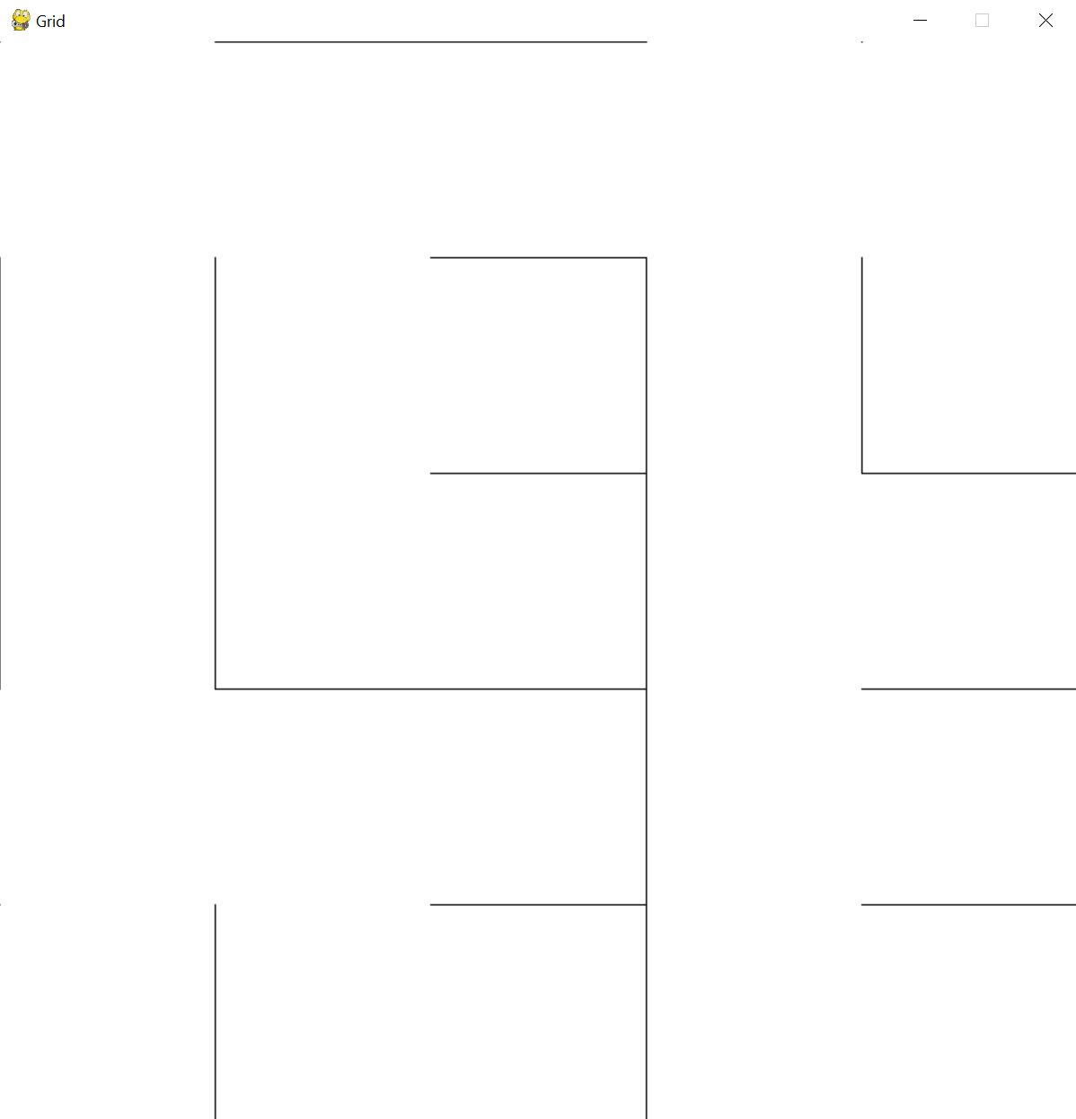5x5 Maze:

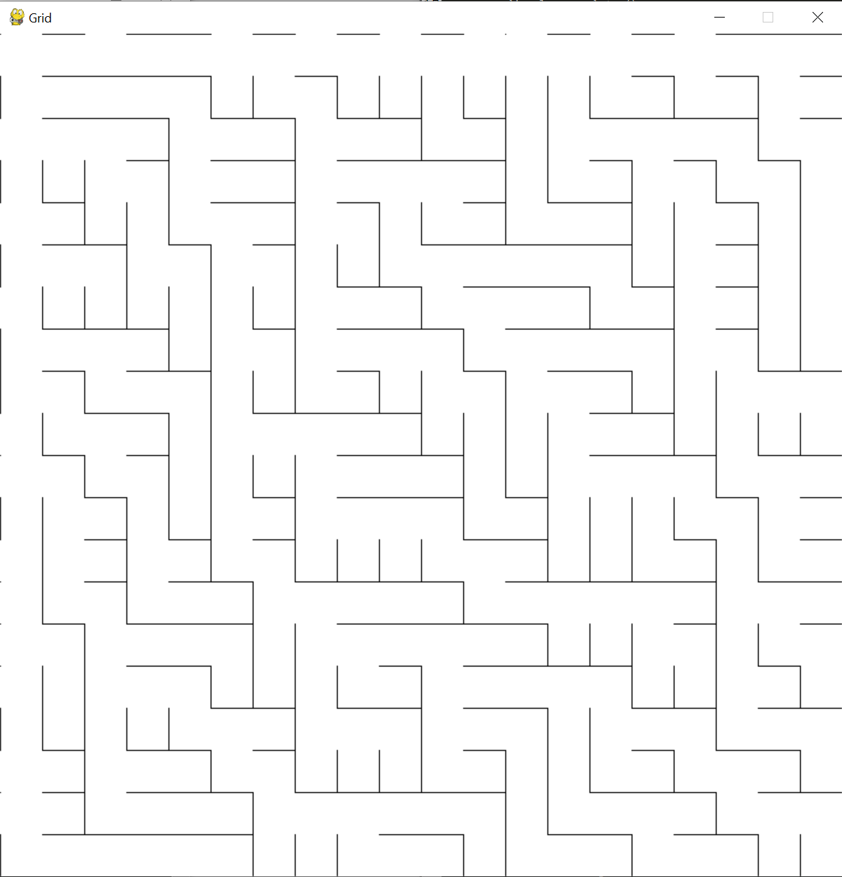20x20 Maze: